Design of BC and RT Memory Management Subsystem for MIL-STD-1553 Using FSM and Dual-Port SRAM

1. Introduction
This design implements the memory management and protocol control layer of a MIL-STD-1553 Bus Controller (BC) and Remote Terminal (RT). The objective of this subsystem is to provide structured buffering of transmit and receive data, controlled by finite state machines (FSMs), and to filter invalid or out-of-sequence data at the word level.
The implementation focuses on:
- Separate memory buffers for BC and RT
- Independent transmit (TX) and receive (RX) paths
- FSM-controlled access to memory
- Protocol-level data validation and garbage data filtering
The physical layer (Manchester encoding, bus interface, and line drivers) is intentionally excluded, as the scope of this work is limited to the terminal logic and memory management layer.

2. Overall Architecture
The architecture consists of the following major blocks:
- BC_FSM: Bus Controller protocol control FSM
- RT_FSM: Remote Terminal protocol control FSM
- Four dual-port SRAM blocks:
  - BC_TX_RAM
  - BC_RX_RAM
  - RT_TX_RAM
  - RT_RX_RAM
Each terminal (BC and RT) uses two dedicated memories:
Terminal | Transmit Buffer | Receive Buffer
BC | BC_TX_RAM | BC_RX_RAM
RT | RT_TX_RAM | RT_RX_RAM
All memories are implemented using dual-port SRAM to allow simultaneous access by:
- FSM (protocol side)
- CPU or test interface (configuration side, optional)
The FSM directly controls one port of each SRAM, while the second port can be used by a CPU or left unused in the current design.

3. Role of Each Memory Block

3.1 BC_TX_RAM
Purpose:
Stores transmit data that the Bus Controller will send to a Remote Terminal.
Access pattern:
- Port B: Read-only by BC_FSM during transmission
- Port A: Optional write access by CPU for preloading data
Function:
The BC_FSM reads words sequentially from BC_TX_RAM based on:
- Subaddress
- Word count
- Current transmit state

3.2 BC_RX_RAM
Purpose:
Stores data received by the Bus Controller from a Remote Terminal.
Access pattern:
- Port B: Write-only by BC_FSM during reception
- Port A: Optional read access by CPU after transfer completion
Function:
The BC_FSM writes only valid received words into BC_RX_RAM, filtering out garbage data when:
- No active receive command
- Word count exceeded
- Unexpected direction

3.3 RT_TX_RAM
Purpose:
Stores transmit data that the Remote Terminal will send back to the Bus Controller.
Access pattern:
- Port B: Read-only by RT_FSM
- Port A: Optional write access by CPU
Function:
The RT_FSM reads words sequentially from RT_TX_RAM when responding to a valid BC command.

3.4 RT_RX_RAM
Purpose:
Stores data received by the Remote Terminal from the Bus Controller.
Access pattern:
- Port B: Write-only by RT_FSM
- Port A: Optional read access by CPU
Function:
The RT_FSM writes received data into RT_RX_RAM only when:
- A valid command has been decoded
- The terminal is in RX_ACTIVE state
- The word index is within the commanded word count

4. FSM to SRAM Connections
Each FSM directly controls the protocol-side port (Port B) of its associated memories.

4.1 RT_FSM Connections

RT_TX_RAM (Read Path)
RT_FSM Signal | RT_TX_RAM Pin | Direction
rt_tx_bus_addr | B_ADDR | FSM → RAM
rt_tx_bus_data | B_DOUT | RAM → FSM
Constant '0' | B_WEN | Disable write
Constant 0 | B_DIN | Unused
Function:
RT_FSM reads transmit data from RT_TX_RAM during RT transmit operations.

RT_RX_RAM (Write Path)
RT_FSM Signal | RT_RX_RAM Pin | Direction
rt_rx_bus_addr | B_ADDR | FSM → RAM
rt_rx_bus_data | B_DIN | FSM → RAM
rt_rx_bus_we | B_WEN | FSM → RAM
Not connected | B_DOUT | Unused
Function:
RT_FSM writes received data words into RT_RX_RAM only when valid.

4.2 BC_FSM Connections

BC_TX_RAM (Read Path)
BC_FSM Signal | BC_TX_RAM Pin | Direction
bc_tx_bus_addr | B_ADDR | FSM → RAM
bc_tx_bus_data | B_DOUT | RAM → FSM
Constant '0' | B_WEN | Disable write
Constant 0 | B_DIN | Unused
Function:
BC_FSM reads transmit data from BC_TX_RAM when sending commands or data.

BC_RX_RAM (Write Path)
BC_FSM Signal | BC_RX_RAM Pin | Direction
bc_rx_bus_addr | B_ADDR | FSM → RAM
bc_rx_bus_data | B_DIN | FSM → RAM
bc_rx_bus_we | B_WEN | FSM → RAM
Not connected | B_DOUT | Unused
Function:
BC_FSM writes received data from RT into BC_RX_RAM.

5. FSM Functional Behavior
Both BC_FSM and RT_FSM implement protocol-level control, including:
- Command decode
- Subaddress extraction
- Word count handling
- Direction control (TX/RX)
- State sequencing:
  - IDLE
  - RX_ACTIVE
  - TX_ACTIVE

Garbage Data Filtering
The FSMs implement protocol-level filtering by:
- Ignoring RX data when not in RX_ACTIVE state
- Stopping writes when word count is reached
- Resetting counters on new command
- Asserting write enable only in valid states
This ensures that:
- No data is written outside commanded transfers
- Invalid or spurious words are discarded
- Memory contents remain protocol-consistent

6. Data Flow Summary

BC to RT Transfer
BC_TX_RAM → BC_FSM → (future Manchester encoder) → Bus → (future decoder) → RT_FSM → RT_RX_RAM

RT to BC Transfer
RT_TX_RAM → RT_FSM → (future Manchester encoder) → Bus → (future decoder) → BC_FSM → BC_RX_RAM
In the current scope, only the memory management and FSM layers are implemented.

7. Clocking
All FSMs and SRAM blocks are clocked by a common system clock derived from the PolarFire Clock Conditioning Circuit (CCC):
clk_sys → BC_FSM
clk_sys → RT_FSM
clk_sys → All four SRAM blocks
This ensures synchronous operation and deterministic memory access timing.

8. Memory Subsystem Consideration
A separate memory subsystem is not used in this design.
Reason:
- Each memory is accessed by only two masters:
  - One FSM
  - One optional CPU port
Dual-port SRAM already provides:
- Safe concurrent access
- No arbitration required
- No additional latency
Introducing a memory subsystem would:
- Add unnecessary complexity
- Introduce arbitration logic
- Increase latency
- Provide no functional benefit for this architecture
Therefore, direct FSM-to-SRAM connections are used.

9. When a Memory Subsystem Is Required
A memory subsystem becomes necessary only when:
- More than two masters share a memory
- Arbitration and priority control are required
- Standard buses (AHB/AXI) are used
- DMA or debug agents are added
Such conditions are not present in this design.

10. Conclusion
This work implements the memory management and control layer of a MIL-STD-1553 terminal, consisting of:
- Separate BC and RT FSMs
- Four dedicated TX/RX dual-port SRAM buffers
- Protocol-level data validation and garbage data filtering
- Clean separation of transmit and receive paths
This subsystem forms a reusable and verifiable core for future integration with:
- Manchester encoder/decoder
- Physical bus interface
- CPU control logic

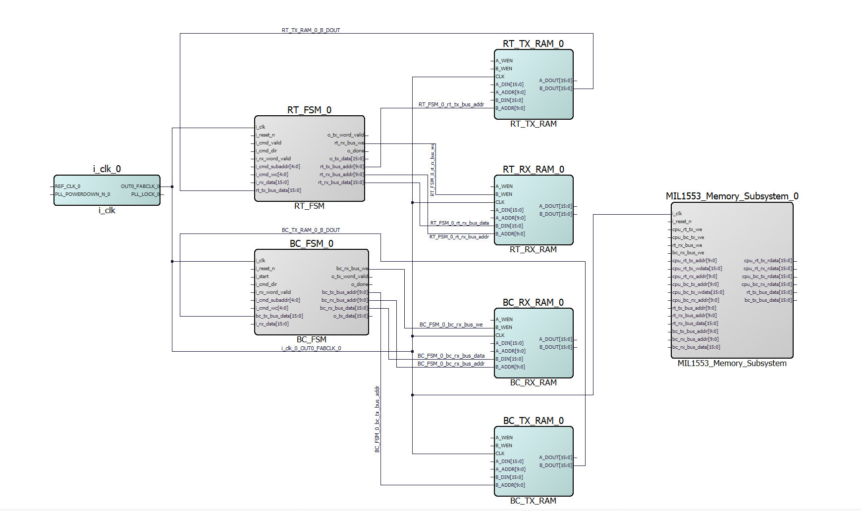

FSM + COUNTER WORD CODE :

library IEEE;
use IEEE.std_logic_1164.all;
use IEEE.numeric_std.all;

entity RT_FSM is
port (
i_clk : in std_logic;
i_reset_n : in std_logic;

-- Command interface (from command decoder)
i_cmd_valid : in std_logic;
i_cmd_dir : in std_logic; -- 0 = RX, 1 = TX
i_cmd_subaddr : in unsigned(4 downto 0); -- 0..31
i_cmd_wc : in unsigned(4 downto 0); -- 0..31 (0 = 32)

-- RX data from bus
i_rx_word_valid : in std_logic;
i_rx_data : in std_logic_vector(15 downto 0);

-- TX data to bus
o_tx_data : out std_logic_vector(15 downto 0);
o_tx_word_valid : out std_logic;

-- Interface to Memory Subsystem
rt_tx_bus_addr : out std_logic_vector(9 downto 0);
rt_tx_bus_data : in std_logic_vector(15 downto 0);

rt_rx_bus_addr : out std_logic_vector(9 downto 0);
rt_rx_bus_data : out std_logic_vector(15 downto 0);
rt_rx_bus_we : out std_logic;

-- Status
o_done : out std_logic
);
end entity;

architecture rtl of RT_FSM is

type state_type is (IDLE, RX_ACTIVE, TX_ACTIVE);
signal state : state_type := IDLE;

signal word_cnt : unsigned(5 downto 0) := (others => '0'); -- 0..32
signal max_words : unsigned(5 downto 0) := (others => '0');

signal base_addr : unsigned(9 downto 0) := (others => '0');

begin

process(i_clk)
begin
if rising_edge(i_clk) then
if i_reset_n = '0' then
state <= IDLE;
word_cnt <= (others => '0');
max_words <= (others => '0');
rt_rx_bus_we <= '0';
o_tx_word_valid<= '0';
o_done <= '0';

else
-- Defaults
rt_rx_bus_we <= '0';
o_tx_word_valid <= '0';
o_done <= '0';

case state is

--------------------------------------------------
-- IDLE : Wait for command
--------------------------------------------------
when IDLE =>
word_cnt <= (others => '0');

if i_cmd_valid = '1' then
-- Decode WC (0 means 32)
if i_cmd_wc = 0 then
max_words <= to_unsigned(32, 6);
else
max_words <= resize(i_cmd_wc, 6);
end if;

-- Compute base address = subaddr * 32
base_addr <= resize(i_cmd_subaddr, 10) sll 5;

if i_cmd_dir = '0' then
state <= RX_ACTIVE;
else
state <= TX_ACTIVE;
end if;
end if;

--------------------------------------------------
-- RX_ACTIVE : Receive data words into RT_RX_RAM
--------------------------------------------------
when RX_ACTIVE =>
if i_rx_word_valid = '1' then
-- Address = base + word_cnt
rt_rx_bus_addr <= std_logic_vector(base_addr+word_cnt);
rt_rx_bus_data <= i_rx_data;
rt_rx_bus_we <= '1';

if word_cnt = max_words - 1 then
o_done <= '1';
state <= IDLE;
else
word_cnt <= word_cnt + 1;
end if;
end if;

--------------------------------------------------
-- TX_ACTIVE : Read data words from RT_TX_RAM
--------------------------------------------------
when TX_ACTIVE =>
-- Address = base + word_cnt
rt_tx_bus_addr <= std_logic_vector(base_addr + word_cnt);
o_tx_data <= rt_tx_bus_data;
o_tx_word_valid<= '1';

if o_tx_word_valid = '1' then
if word_cnt = max_words - 1 then
o_done <= '1';
state <= IDLE;
else
word_cnt <= word_cnt + 1;
end if;
end if;

end case;
end if;
end if;
end process;

end architecture;
MEMORY SUBSYSTEM CODE :

library IEEE;
use IEEE.std_logic_1164.all;
use IEEE.numeric_std.all;

entity MIL1553_Memory_Subsystem is
port (
--------------------------------------------------
-- Clock & Reset
--------------------------------------------------
i_clk : in std_logic;
i_reset_n : in std_logic;

--------------------------------------------------
-- CPU interface (Port A of all RAMs)
--------------------------------------------------
cpu_rt_tx_addr : in std_logic_vector(9 downto 0);
cpu_rt_tx_wdata : in std_logic_vector(15 downto 0);
cpu_rt_tx_we : in std_logic;
cpu_rt_tx_rdata : out std_logic_vector(15 downto 0);

cpu_rt_rx_addr : in std_logic_vector(9 downto 0);
cpu_rt_rx_rdata : out std_logic_vector(15 downto 0);

cpu_bc_tx_addr : in std_logic_vector(9 downto 0);
cpu_bc_tx_wdata : in std_logic_vector(15 downto 0);
cpu_bc_tx_we : in std_logic;
cpu_bc_tx_rdata : out std_logic_vector(15 downto 0);

cpu_bc_rx_addr : in std_logic_vector(9 downto 0);
cpu_bc_rx_rdata : out std_logic_vector(15 downto 0);

--------------------------------------------------
-- RT FSM interface (Port B of RT RAMs)
--------------------------------------------------
rt_tx_bus_addr : in std_logic_vector(9 downto 0);
rt_tx_bus_data : out std_logic_vector(15 downto 0);

rt_rx_bus_addr : in std_logic_vector(9 downto 0);
rt_rx_bus_data : in std_logic_vector(15 downto 0);
rt_rx_bus_we : in std_logic;

--------------------------------------------------
-- BC FSM interface (Port B of BC RAMs)
--------------------------------------------------
bc_tx_bus_addr : in std_logic_vector(9 downto 0);
bc_tx_bus_data : out std_logic_vector(15 downto 0);

bc_rx_bus_addr : in std_logic_vector(9 downto 0);
bc_rx_bus_data : in std_logic_vector(15 downto 0);
bc_rx_bus_we : in std_logic
);
end entity;

architecture rtl of MIL1553_Memory_Subsystem is

--------------------------------------------------
-- Internal signals for SRAM outputs
--------------------------------------------------

-- RT_TX_RAM
signal rt_tx_ram_a_dout : std_logic_vector(15 downto 0);
signal rt_tx_ram_b_dout : std_logic_vector(15 downto 0);

-- RT_RX_RAM
signal rt_rx_ram_a_dout : std_logic_vector(15 downto 0);

-- BC_TX_RAM
signal bc_tx_ram_a_dout : std_logic_vector(15 downto 0);
signal bc_tx_ram_b_dout : std_logic_vector(15 downto 0);

-- BC_RX_RAM
signal bc_rx_ram_a_dout : std_logic_vector(15 downto 0);

begin

--------------------------------------------------
-- RT_TX_RAM_0
-- CPU writes (Port A), RT FSM reads (Port B)
--------------------------------------------------
RT_TX_RAM_0 : entity work.PF_DPSRAM
port map (
-- Port A : CPU side (write/read)
A_ADDR => cpu_rt_tx_addr,
A_DIN => cpu_rt_tx_wdata,
A_WEN => cpu_rt_tx_we,
A_DOUT => rt_tx_ram_a_dout,

-- Port B : RT FSM side (read-only)
B_ADDR => rt_tx_bus_addr,
B_DIN => (others => '0'),
B_WEN => '0',
B_DOUT => rt_tx_ram_b_dout,

-- Clock
CLK => i_clk
);

-- Drive outputs
cpu_rt_tx_rdata <= rt_tx_ram_a_dout;
rt_tx_bus_data <= rt_tx_ram_b_dout;

--------------------------------------------------
-- RT_RX_RAM_0
-- RT FSM writes (Port B), CPU reads (Port A)
--------------------------------------------------
RT_RX_RAM_0 : entity work.PF_DPSRAM
port map (
-- Port A : CPU side (read-only)
A_ADDR => cpu_rt_rx_addr,
A_DIN => (others => '0'),
A_WEN => '0',
A_DOUT => rt_rx_ram_a_dout,

-- Port B : RT FSM side (write-only)
B_ADDR => rt_rx_bus_addr,
B_DIN => rt_rx_bus_data,
B_WEN => rt_rx_bus_we,
B_DOUT => open,

-- Clock
CLK => i_clk
);

-- Drive output
cpu_rt_rx_rdata <= rt_rx_ram_a_dout;

--------------------------------------------------
-- BC_TX_RAM_0
-- CPU writes (Port A), BC FSM reads (Port B)
--------------------------------------------------
BC_TX_RAM_0 : entity work.PF_DPSRAM
port map (
-- Port A : CPU side (write/read)
A_ADDR => cpu_bc_tx_addr,
A_DIN => cpu_bc_tx_wdata,
A_WEN => cpu_bc_tx_we,
A_DOUT => bc_tx_ram_a_dout,

-- Port B : BC FSM side (read-only)
B_ADDR => bc_tx_bus_addr,
B_DIN => (others => '0'),
B_WEN => '0',
B_DOUT => bc_tx_ram_b_dout,

-- Clock
CLK => i_clk
);

-- Drive outputs
cpu_bc_tx_rdata <= bc_tx_ram_a_dout;
bc_tx_bus_data <= bc_tx_ram_b_dout;

--------------------------------------------------
-- BC_RX_RAM_0
-- BC FSM writes (Port B), CPU reads (Port A)
--------------------------------------------------
BC_RX_RAM_0 : entity work.PF_DPSRAM
port map (
-- Port A : CPU side (read-only)
A_ADDR => cpu_bc_rx_addr,
A_DIN => (others => '0'),
A_WEN => '0',
A_DOUT => bc_rx_ram_a_dout,

-- Port B : BC FSM side (write-only)
B_ADDR => bc_rx_bus_addr,
B_DIN => bc_rx_bus_data,
B_WEN => bc_rx_bus_we,
B_DOUT => open,

-- Clock
CLK => i_clk
);

-- Drive output
cpu_bc_rx_rdata <= bc_rx_ram_a_dout;

end architecture;

